Sep 27, 2026
Lecture #1: Fundamentals of Testing
- Difference between QA, QC, and Tester in the software process
- QA is a process-oriented (preventive approach) Focus on implementation and improvement of process  - QC is a product-oriented (model checking, proof of correctness), simulation, and prototype Focus on process running as expected  - Testing is a part of QC and supports the goals of quality level  - Testers aim to find failures by breaking software | 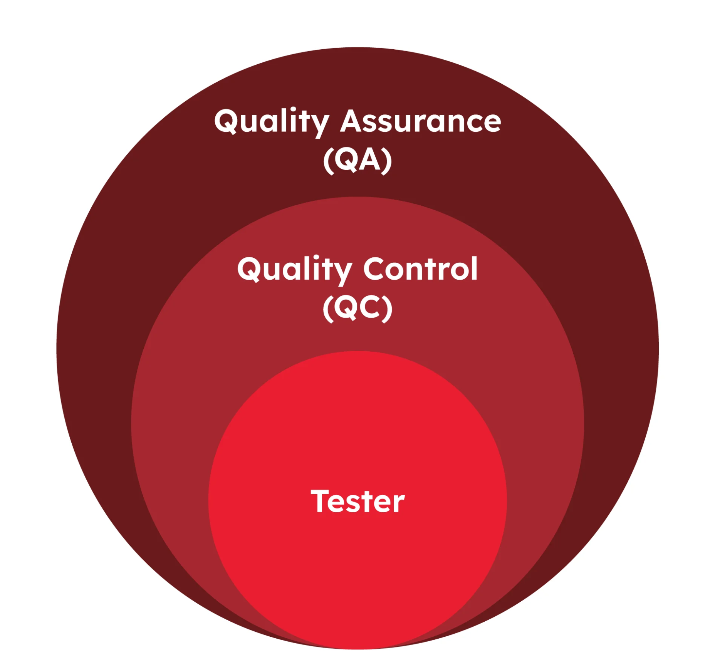
- Test objectives
- Test objectives = why do we test?
- Purpose of testing:
- Evaluate work products to find defects
- Verify that specified requirements are fulfilled
- Validate that the product meets user needs and expectations
- Build confidence in the quality of the product
- Reduce risks related to software quality
- Provide information for decision-making
- Ensure compliance with contractual, legal, and regulatory requirements
- Testing is not only about finding bugs
- Testing cannot prove the absence of defects
- Testing # Debugging:
- Testing identifies failures
- Debugging finds causes and fixed defects
- Test objectives depend on the context, risks, and project goals
- Early testing helps reduce the cost of fixing defects
- Distinguish between error, defect, and failure
- Errors: mistake made by humans that create an incorrect result  - Defects: an error in the software, maybe an error in the code, analysis requirements, or design architecture (documentation/technical things)  - Failure: misbehaves during execution, causing the product to crash, wrong result, or not meet the requirement or system ==> not all defects may always cause failures  - Root cause: a fundamental reason for the occurrence of a problem | 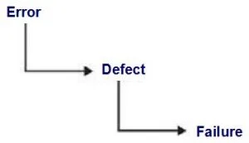  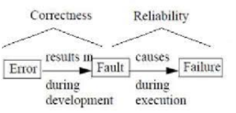
- Test roles
- Test Management Role (Focuses on managing the testing process)
- Plan testing activities
- Monitor and control testing progress
- Analyze, estimate, and prioritize testing
- Manage test resources and risks
- Report test progress and results
- Coordinate testing activities
- Testing role (Focuses on technical testing activities)
- Analyze the test basis
- Design and implement test cases and test procedures
- Execute tests
- Evaluate test results and report defects
- Maintain testware and test environments
- Essential skills of a tester
- Testing knowledge: Understand testing principles, techniques, and processes
- Thoroughness and attention to detail: Identify defects and inconsistencies
- Communication skills: Communicate findings clearly and constructively
- Analytical skills: Analyze information and solve problems
- Critical thinking: Question assumptions and evaluate alternatives
- Technical knowledge: Understand tools, technologies, and test environments
- Domain knowledge: Understand the business and application being tested
- Teamwork skills: Collaborate effectively with developers and stakeholders
- Curiosity and learning: Continuously improve knowledge and skills
- Testing Principles (7 principles)
- Test activity
Test activity | What happens
Test planning | Define scope, strategy, resources
Test monitoring & control | Track progress and adjust plans
Test analysis | Identify what to test
Test design | Design test cases and test data
Test implementation | Prepare environment and finalize testware
Test execution | Run test and log result
Test completion | Final reports, clean-up, lessons learned
- Test process and Testware
- Test process: help fulfill stakeholders' business needs (exhaustive and risk-based testing)
- Testware: create as output work products from the test activites
 | Test process | Testware
Definition | A structured set of activities carried out during testing | All artifacts produced or used during the test process
Focus | How testing is done → activities & workflow | What is created or used during testing → documents, tools, data
Purpose | To organize and manage testing | To support, document, and execute the testing process
Example | Testing planning, analysis execution, closure | Test cases, test data, test scripts, defect reports, traceablitity
Reusability | Process is followed again, but not reused as-is | Testware is reusable and maintainable across test cycles
Who uses it | Followed by the entire test team | Created/used by testers, dev, QA
- Traceability purpose
- Traceability of test case - requirement: verify the requirements are covered by test cases
- Traceability of matrix: map test cases—corresponding requirements/design elements
- Traceability of test results-risks: level of residual risk in a test object
- Verification and Validation
- Verification: checking whether the system meets specified requirements + assess quality
- Validation: checking whether the system meets users' and other stakeholders' needs in its operational environment
- Whole team approach
- Quality is the responsibility of the whole team, not only testers
- The approach encourages collaboration, not isolated work
- Benefits:
+ Better communication and collaboration
+ Shared responsibility for product quality
+ Faster defect detection and resolution
+ Reduced silos and misunderstandings
+ Better use of team skills and knowledge
+ Improved product quality and efficiency
- Levels of Indepence of Testing
- More independence does not always mean better testing
- Developers testing their own code can still be effective
- Independence can help find different defects, but collaboration remains important
- The appropriate level depends on risk, context, and project needs

Sep 28, 2026
Lecture #2: SDLC and SDTC

- Testing in the Context of a Software Development Lifecycle

Software development activities | Software test activities
- Activities performed in a software development project  - These depend on the SDLC method | - For every development activity, there is a corresponding test activity  - Each test level has specific objectives for that level  - Test analysis and design begin corresponding to the development activity  - Testers take part in discussions to define and refine requirements and design

 | TDD | ATDD | BDD
Focus | Code functionality | Acceptance critearia | System behaviour (functional level)
Language | Code-based | Natural language or structured | Gerkin (natural language)  - Given When Then" format
Participants | Only Dev | Business + Tester + Dev | Busniness + Tester + Dev

- DevOps vs Testing
 | DevOps | Testing
Main goal | Deliver software faster and more reliably | Find defects and evaluate quality
Focus | Collaboration, automation, continuous delivery and deployment | Defect detection, verification and validation
Activities | CI/CD pipelines, infrastructure automation, monitoring and deployment | Test planning, test design, execution and defect reporting
Outcome | Faster, more reliable software delivery | Information about software quality and risks

- Test level: Groups of test activities that are organized and managed together
- Unit test (component testing) →  - Test object: Components (smallest units of software)  - Typical defect: Incorrect functionality, data flow problems,  - Test basis: Code, detailed design, user stories, component specifications  - Technique: Black box testing, White box testing, Experience-base techinques  - Component Integration test (Focus: component - to component interactions)  - Test object: Database, API, (test the interfaces and interactions between component)  - Typical defect: Incorrect data, interface mismatch, incorrect assumptions abt component interactions  - Test basic: Software architecture, component design, interface specifications,  - Techniques: Black box testing, white box testing,...  - System test  - Test object: Applications, operating systems  - Typical defect: Incorrect or unexpected system behaviour,  - Test basic: SRS, Risk analysis reports  - Technique: Black box testing,...  4 System Integration Testing  - Test object: Interfaces and interactions between the system under test and external systems  - Typical defect: Communication failures, incorrect data formats, interface mismatches,  - Test basic: System architecture, interface specifications, communication protocols, workflows  - Techniques: Black box testing, white box tesing,...  5 Acceptance test  - Test object:  - Complete system or a specific system configuration  - Backup and restore, non-functional requirement  - Typical defect: System workflow doesn’t meet business requirements, incorrect business rules, system doesn’t satisfy regulation,  - Technique: Black box testing | 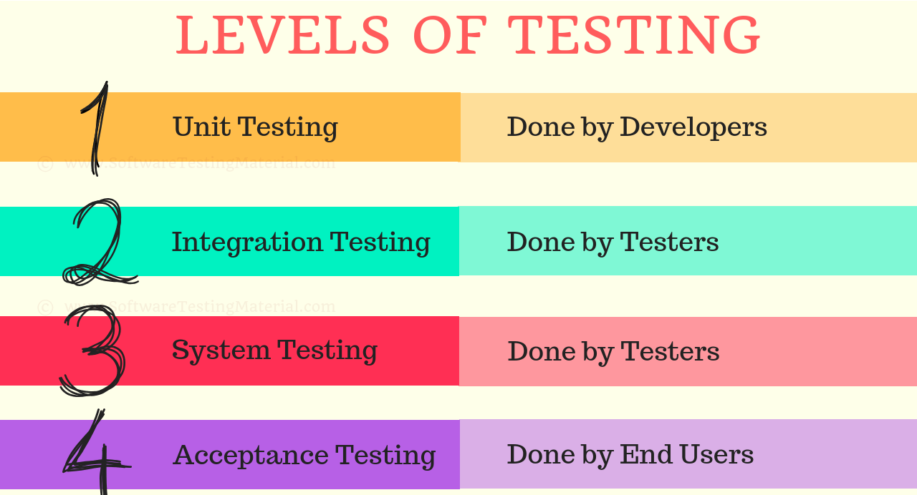  key distinction:  - Component → individual component  - Component Integration → interactions between components  - System → complete system  - System Integration → interactions between systems  - Acceptance → business needs and readiness for use

- Test type: different categories of testing that focus on what aspect of software is being tested
- Functional testing:
- Test which evaluates functions that the system should perform
- Test what the system/test object should do
- Non-functional:
- Evaluates usability, performance, security
- Test how the system does its job
- Black-box testing:
- Checking the system behavior against its specifications
- White-box testing
- Evaluates code, architecture, workflows, and data flow within the system Give a percentage of coverage
- Confirmation testing and regression testing
- Confirmation testing: testing that runs the same test cases that failed earlier to confirm that the failure has been fixed
- Regression testing: testing that make sure the new changes (like bug fixed or enhancements) haven’t broken existing functionalities
- Maintenance
- Modification: Changes made to the software system
- Corrections: fixing defects or bugs identified in the operational system
- Enhancements: Adding new feature or improving existing ones (part of planned release or unplanned hotfixes)
- Adaptions: Changes needed due to alterations in the operational environment
- Migration:
- Moving the software system from one platform or environment to another
- This necessitates testing in the new environment
- Retrospectives and process improvement
- Retrospectives (a meeting held to reflect on completed work and identify improvements)
- Discuss what went well, what went wrong and what can be improved
- Involve the whole team, including testers and developers
- Focus on learning, not blaming individuals
- Take place at the end of iteration, release or project
- Process improvement
- Identify problems and areas for improvement
- Analyze root causes
- Define improvement actions
- Implement agreed actions
- Evaluate results and effectiveness
- Benefits
- Improve testing and development processes
- Prevent recurring(tái diễn, lặp lại) defects and problems
- Enhance teamwork and communication
- Increase efficiency and product quality
- Promote continuous learning and improvement

Sep 30, 2026
Lecture #3+4: Static Testing
- Static Testing Basics
- A method of software testing where the - code is not executed
- Code, documentation, or other work products are examined by reviewing by humans or using tools to find defects
- Static testing applies to both code and non-code work products
- Static testing can detect defects early and reduce the cost of fixing them
- Static vs Dynamic Testing
 | Static testing | Dynamic testing
Code Execution | No execution required | Code must be executed
When Performed | Early in SDLC | After code is written
What is Tested | Code, documents, specs | Running software/system
Methods | Reviews, walkthroughs, static analysis tools | Test execution using tools or manual efforts
Defect Types Found | Syntax errors, design flaws, standard violations | Runtime errors, functional bugs, performance issues
Cost of Fixing | Lower (issues found early) | Higher (issues found later in cycle)
Focus | Structure, consistency, and correctness | Behavior, output, and user interaction
Involvement | Manual review by developers/testers, automated tools | Mostly automated tools, manual test case execution

